# # # # # # # # # # # # # # # # # # # # # # # # # # # # # # # # # # # # # # # # # # # # # #

Brain Age GWAS – Phenotype Construction
ENIGMA Working Group
Local version – December 16, 2024
# # # # # # # # # # # # # # # # # # # # # # # # # # # # # # # # # # # # # # # # # # # # # #

Step 0: Set up

You will need the following files to run the analysis:

Provided by us:
- Singularity container 'enigma-container-with-r2.sif'
- 'functions' folder
- 'scripts' folder
- 'photon_models' folder

Prepared by you (see Step 1 for details):
- 'Covariates.csv'
- 3 FreeSurfer files ('CorticalMeasuresENIGMA_SurfAvg.csv', 'CorticalMeasuresENIGMA_ThickAvg.csv', 'SubcorticalMeasuresENIGMA_VolAvg.csv')

You need to keep these files/folders inside 'ENIGMA-brainage-local' folder.

Please make sure that you have already done QA on the cortical and subcortical measures according to the previous ENIGMA protocols. If you need help with this, please contact us.

Step 1: Prepare files

Please, make sure to have exactly the same header labels as shown in the example screenshots so that the commands used in this protocol need not to be changed!
Please see the header.xlsx file for a complete list of headers for all files.
All csv-files should be comma (“,” - without the quotes) delimited!

CorticalMeasuresENIGMA_ThickAvg.csv, which contains your cortical thickness imaging phenotypes (after quality control).

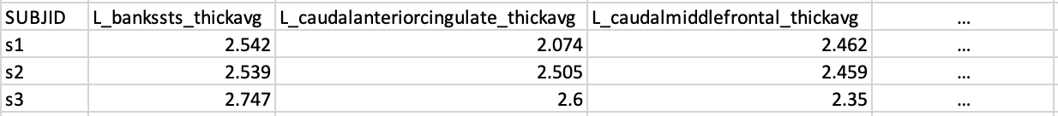

CorticalMeasuresENIGMA_SurfAvg.csv, which contains your surface area imaging phenotypes (after quality control).

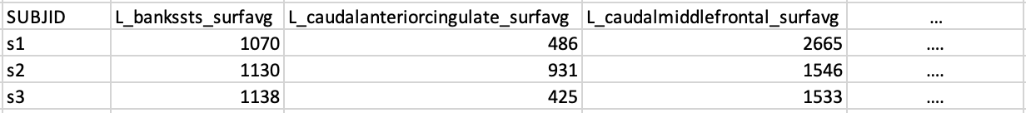

SubcorticalMeasuresENIGMA_VolAvg.csv, which contains your subcortical volume imaging phenotypes (after quality control).

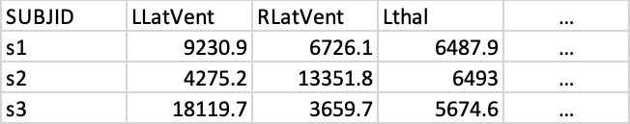

Make sure that missing values and measures that were excluded from the analysis during QC are coded as “NA” without the quotes.

Covariates.csv, which contains the full set of variables we will be controlling for in each of the models. Please, make sure to have exactly the same header labels as shown in the example screenshot below (also see header.xlsx for a complete list). You will need to make this file. Missing values in the covariate columns are coded as “NA” without the quotes. The IDs in the SUBJID column should match the format of the IDs in the SUBJID column in the CorticalMeasuresENIGMA_>brain.measure<.csv files.
In Excel, or your favorite text editor, create a series of columns with the following headers:
Mandatory columns are:
Header | Explanation
SUBJID | Subject IDs (same as in CorticalMeasuresENIGMA_ThickAvg.csv)
DX | Controls are coded as 0 and Cases are coded as 1  (for non-case/control studies include an NA)
SEX | Men are coded as 0 and Women are coded as 1
AGE | Age in years
PC1 | Genetic principal component 1
PC2 | Genetic principal component 2
PC3 | Genetic principal component 3
PC4 | Genetic principal component 4
…. | ….
PC10 | Genetic principal component 10

Optional columns (for additional models and descriptives):
If any of these are not available, include the header and add 'NA' as data points. For the case-related variables, please add 'NA' for healthy control participants – do not code as “0” (=zero).
- The Site column is only required if your sample requires correction for data collection at different sites/scanners. Please only include ONE site column, using numbers to indicate, which participant came from which site. We will turn this into dummy variables in the script itself. If you have no site variables to include, do not include a site column.
SITE | Only needed, if your data was measured at different locations / different scanners. Use only ONE site column, coding for n number of sites (see example covariate file below)

- Additional measures:
IQ | IQ (ideally premorbid in cases/control studies)
HAND | Handedness, coded as: 0 right; 1 left; 2 ambidexter
ETHNICITY | Ethnicity
ANCESTRY | Self-reported ancestry; options include:  African, Asian (East Asian/South Asian), Hispanic or Latin American, European, Other (please specify)
SES | Socio-economic status
DISEASE_CATEGORY | Current disease category (for case/control studies);  For example: MDD, ADHD, SCZ

- Your covariate file should look similar to this (only comma-separated):

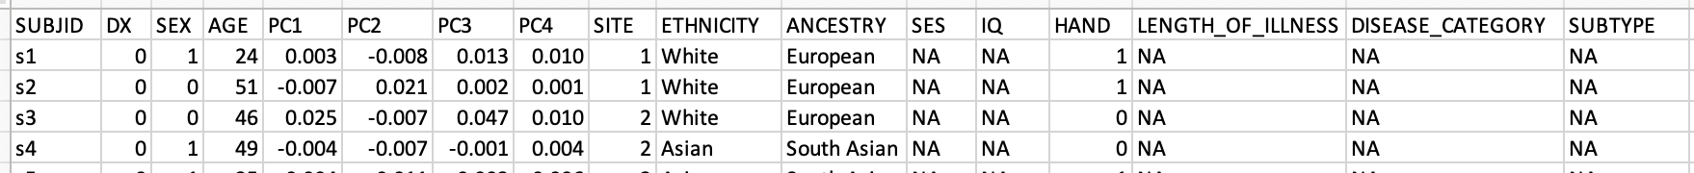

Please also see the 'practice_data' folder for an example of the input data.

Step 2: Obtain measures of brain age
- Run the analysis inside the Singularity container, which comes with R and python pre-installed with all required packages:

# Load singularity (replace with your version of singularity)
module load Singularity/4.0.0

# Export cache (if you have no disk space in the default cache directory)
export SINGULARITY_CACHEDIR=/your/chosen/path/.singularity/cache

# Run singularity
cd ENIGMA-brainage-local
singularity shell enigma-container-with-r2.sif

# Run Script 1
# will produce 'males_raw.csv' and 'females_raw.csv' files and save them in 'rawfiles' folder
/usr/bin/Rscript scripts/1_protocol_brainAge_ENIGMA_local_20241216.R

# Run Script 2
# will produce 'males_raw_out.csv' and 'females_raw.csv_out' files and save them in 'enigma-predictions' folder
mkdir -p enigma-predictions
python3 scripts/2_protocol_brainAge_ENIGMA_local_20241216.py \
--modelfolder photon_models \
--rawfolder rawfiles \
--predictionfolder enigma-predictions

# Output files look just like your input files with an additional column called 'age_prediction'.

Step 3: QC and basic stats for your brainAge measure + regression models

# Run Script 3
# will produce descriptives and regression model outputs
/usr/bin/Rscript scripts/3_protocol_brainAge_ENIGMA_local_20241216.R

Step 4: Run brainAge-ROI correlation analyses
# Run Script 4
# will obtain correlations for brainAge and each FreeSurfer ROI
/usr/bin/Rscript scripts/4_protocol_brainAge_ENIGMA_local_20241216.R

Step 5: Tidy up and share output
# Move all files to output folders
mkdir -p output-pheno output-backup
mv data_pheno_covariates.Rdata data_covs_tsv.Rdata df_covs_tsv.rds output-backup/
mv *.log *.txt *.rds *.pdf *.R?ata output-pheno/

# Compress the 'output-pheno' folder (saved as UKBB_[date].zip)
zip -r "UKBB_$(date +'%Y%m%d').zip" output-pheno

# Exit singularity
exit

Please send the zipped folder, as well as any information on how you coded your variables (IQ, SES, ethnicity, ancestry, disease category), and any additional feedback/error messages back to: vb506@bath.ac.uk and E.Walton@bath.ac.uk.
Or upload directly to:https://drive.google.com/drive/folders/1jiKW1she3ubA4dthf_tKX-TbYOp80sGr (you might need to request access)

Please ensure that all files are uploaded in one folder and that you have named the folder as follows: CohortName_DATE (e.g., ASRB_20241220)

Important acknowledgments:
If you use PHOTON and the ENIGMA FreeSurfer Brain Age Model for any of your own work, please make sure that you quote the following reference in any publications:
Han, L.K.M., Dinga, R., Hahn, T. et al. Brain aging in major depressive disorder: results from the ENIGMA major depressive disorder working group. Mol Psychiatry (2020). https://doi.org/10.1038/s41380-020-0754-0

